**Advanced Enterprise Network**

**Mixed Routing Design**

Comprehensive network architecture featuring 5 managed switches, 10 workstations, and 6 routers with dual routing protocols, 3 north routers using static routing and 3 right routers implementing OSPF for optimal performance and reliability.

**Digital Egypt Pioneer Initiative (DEPI) graduation project**

**Project Overview**

**Goal:** Design and configure a multi-department enterprise network with VLAN segmentation, routing, and server access using Huawei routers and switches.

**Tools Used:** eNSP

**Devices:** 6 routers, 5 switches, 8 PCs, 2 APs and 2 servers.

**Features implemented:** VLANs, OSPF routing, ACLs, DHCP & FTP servers

**Network Topology Overview**

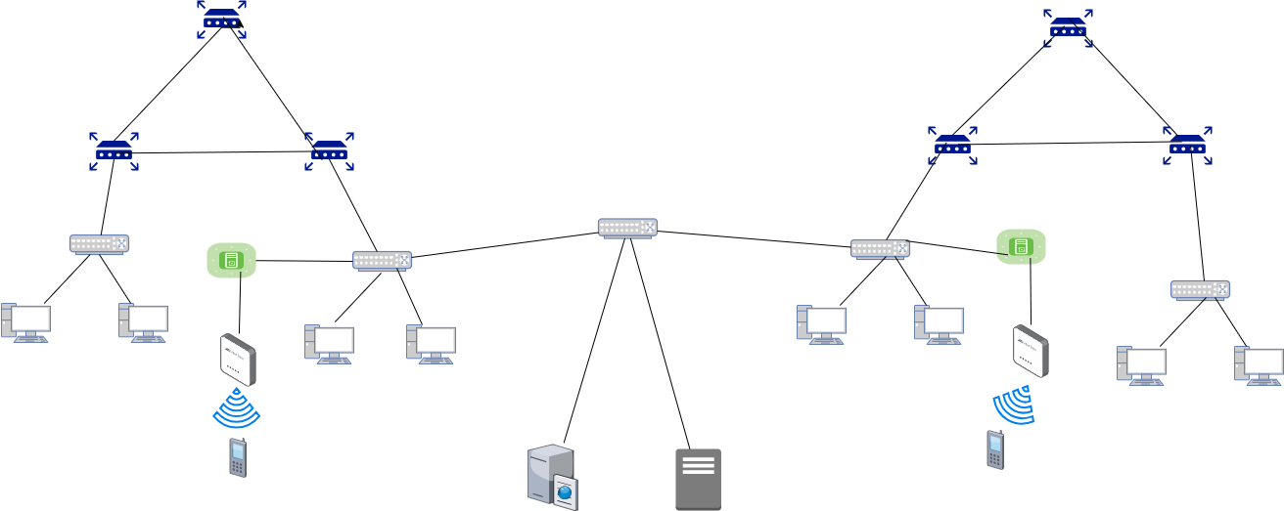

* Six routers configured with dual routing protocols for optimal performance
* Three north routers implementing static routing for predictable paths
* Three right routers using OSPF for dynamic adaptive routing
* Five managed switches providing segmented connectivity for ten workstations

This hybrid network design combines the reliability of static routing with the adaptability of OSPF protocols, providing both predictable traffic flows and dynamic network resilience for enterprise operations.

The mixed routing approach ensures optimal performance while maintaining network stability and providing automatic failover capabilities for critical business operations.

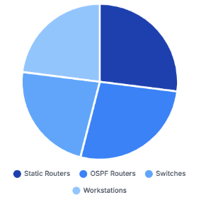

**Device Distribution**

Network infrastructure allocation across routing domains and access layers

**Network Topology Description**

* The network is divided into five VLANs (10, 20, 30, 40, 50).
* There are 6 routers (R1–R6) connected in a hierarchical manner to provide inter-network connectivity.
* 5 switches are used for VLAN segmentation and device access.
* FTP and Web servers are placed in VLAN 50, while users are distributed across VLANs 10–40
* There are 2 access controller and 2 access points providing a wireless communication connection for 2 cell phones.

**Static vs. OSPF Routing**

|  |  |
| --- | --- |
| Static Routing | OSPF Routing |
| Predictable and deterministic routing paths | Automatic topology discovery and path calculation |
| Lower CPU utilization and memory usage | Dynamic adaptation to network changes and failures |
| Simple configuration and management process | Load balancing across multiple equal cost paths |
| No routing protocol overhead or convergence time | Scalable design for large enterprise networks |
| Enhanced security through manual control | Reduced administrative overhead for route maintenance |

**Router Configuration Details**

|  |  |
| --- | --- |
| **North Routers** | **Right Routers** |
| Three routers configured with static routing protocols providing predictable traffic paths, manual route control, and deterministic network behavior for critical business applications requiring consistent performance. | Three routers implementing OSPF dynamic routing with automatic topology discovery, fast convergence capabilities, and adaptive path selection for resilient network operations and failure recovery. |

**Routing Integration**

Strategic combination of static and OSPF protocols ensures optimal traffic distribution while maintaining network stability through redundant pathways and protocol-specific advantages.

**Load Balancing**

Advanced traffic distribution across both routing domains provides enhanced performance, reduced congestion, and improved network utilization through intelligent path selection algorithms.

**Network Hierarchy Architecture**

**Security Framework Implementation**

* **Protocol Security**

OSPF authentication mechanisms, static route validation, and routing protocol isolation ensure secure communication between network domains and prevent unauthorized routing updates.

* **Access Control**

Port-based 802.1X authentication, VLAN segmentation across five switches, and MAC address filtering provide comprehensive access control for ten workstations.

* **Traffic Monitoring**

Real-time monitoring of both static and OSPF routing domains with SNMP protocols, traffic analysis tools, and comprehensive logging systems.

**Implementation Roadmap**

**Switch Infrastructure Overview**

Comprehensive configuration details for the five-switch access layer providing connectivity for ten workstations with VLAN segmentation, traffic management, and redundant uplink connections to router infrastructure.

|  |  |  |  |  |  |  |
| --- | --- | --- | --- | --- | --- | --- |
| Switch ID | Port Count | Connected Devices | VLAN Config | Uplink Target | Bandwidth Util | Status |
| SW-01 | 24 Ports | 2 Workstations | VLAN 10 | Static Router-1 | 28% | Active |
| SW-02 | 24 Ports | 2 Workstations | VLAN 20 | Static Router-2 | 32% | Active |
| SW-03 | 24 Ports | 2 Workstations | VLAN 30 | OSPF Router-1 | 26% | Active |
| SW-04 | 24 Ports | 2 Workstations | VLAN 40 | OSPF Router-2 | 35% | Active |
| SW-05 | 24 Ports | 2 Workstations | VLAN 50 | OSPF Router-3 | 30% | Active |

**IP Addressing & VLAN Table**

|  |  |  |
| --- | --- | --- |
| Device | VLAN | IP Address |
| PC 1 | VLAN 10 | 192.168.3.100 |
| PC 7 | VLAN 10 | 192.168.3.101 |
| PC 2 | VLAN 20 | 192.168.4.100 |
| PC 6 | VLAN 20 | 192.168.4.101 |
| PC 5 | VLAN 30 | 10.200.1.100 |
| PC 8 | VLAN 30 | 10.200.1.101 |
| PC 4 | VLAN 40 | 10.150.1.100 |
| PC 9 | VLAN 40 | 10.150.1.101 |
| FTP Server | VLAN 50 | 192.168.50.100 |
| Web Server | VLAN 50 | 192.168.50.101 |
|  |  |  |
| LSW1 (switch1) | VLAN 10 | 192.168.3.0 |
| LSW2 (switch2) | VLAN 20 | 192.168.4.0 |
| LSW4 (switch4) | VLAN 40 | 10.150.1.0 |
| LSW5 (switch5) | VLAN 30 | 10.200.1.0 |
| LSW7 (switch7) | VLAN 50 | 192.168.50.0 |

**VLAN Configuration**

**On Switch 7**

Vlanif 10

ip address 192.168.3.2 255.255.255.0

vrrp vrid 10 virtual-ip 192.168.3.1

vrrp vrid 10 priority 120

Vlanif 20

ip address 192.168.4.2 255.255.255.0

vrrp vrid 20 virtual-ip 192.168.4.1

vrrp vrid 20 priority 120

Vlanif 30

ip address 10.200.1.2 255.255.255.0

vrrp vrid 30 virtual-ip 10.200.1.2

vrrp vrid 30 priority 120

Vlanif 40

ip address 10.150.1.2 255.255.255.0

vrrp vrid 40 virtual-ip 10.150.1.1

vrrp vrid 40 priority 120

Vlanif 50

ip address 192.168.50.2 255.255.255.0

vrrp vrid 50 virtual-ip 192.168.50.1

vrrp vrid 50 priority 120

**On Switch 5**

Vlanif 10

ip address 192.168.3.3 255.255.255.0

vrrp vrid 10 virtual-ip 192.168.3.1

Vlanif 20

ip address 192.168.4.3 255.255.255.0

vrrp vrid 20 virtual-ip 192.168.4.1

vrrp vrid 20 priority 120

Vlanif 30

ip address 10.200.1.3 255.255.255.0

vrrp vrid 30 virtual-ip 10.200.1.2

Vlanif 40

ip address 10.150.1.3 255.255.255.0

vrrp vrid 40 virtual-ip 10.150.1.1

Vlanif 50

ip address 192.168.50.3 255.255.255.0

vrrp vrid 50 virtual-ip 192.168.50.1

**On Switch 5**

Vlanif 10

ip address 192.168.3.4 255.255.255.0

vrrp vrid 10 virtual-ip 192.168.3.1

Vlanif 20

ip address 192.168.4.4 255.255.255.0

vrrp vrid 20 virtual-ip 192.168.4.1

vrrp vrid 20 priority 120

Vlanif 30

ip address 10.200.1.4 255.255.255.0

vrrp vrid 30 virtual-ip 10.200.1.2

Vlanif 40

ip address 10.150.1.4 255.255.255.0

vrrp vrid 40 virtual-ip 10.150.1.1

Vlanif 50

ip address 192.168.50.4 255.255.255.0

vrrp vrid 50 virtual-ip 192.168.50.1